**Assignment 1 - Make Pong Interface**

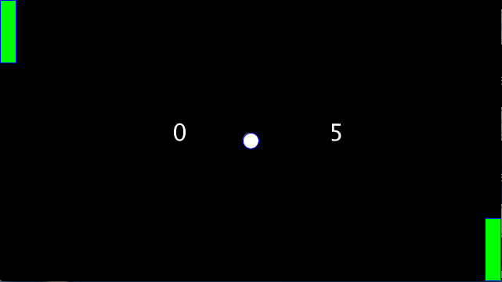

***Note:*** *If you haven’t done so already, go through Lesson: “1.0 Basic Concepts in Processing” and complete “Quiz 1” first before attempting this assignment*

**Goal**

This assignment requires you to use the knowledge from Lesson 1 about drawing shapes and colors to make the interface of the Pong game containing two paddles, a ball and the left and right players’ scores.

**Instructions**

**Code Setup**

Do the following steps carefully. **Note that failure to do so would result in getting a grade of zero for this assignment because AutoGrad won’t be able to grade your work!**

1. Open the program Assignment1, and rename both 1) the program and 2) the tab by adding “**_”** andyour student id at the end like “Assignment1_sa321” as shown in “Course Apps Setup” page 12 and 13. You can get your student id by going to [this link](http://suacode.netlify.app), entering the course id (sa002), and the email you used to sign up for Piazza.
2. Put your ***maxX*** and ***maxY*** values in the comment at the top of the code by replacing the *** with your values.
3. Make sure the ***fullScreen()*** function is within your ***setup()*** function.

**Assignment Specifications (specs)**

Using your Assignment1, write code to draw a Pong game interface like in the picture above with the following specs:

1. Two paddles, one at the top left end **exactly** and one at the bottom right end **exactly**
   1. pick your own width and height but they should be the same for both paddles
   2. **Hint:** If you are struggling to position the right paddle, it means you haven’t fully understood the computer’s coordinate system and how to draw a rectangle. Hence, reread those sections in the notes and importantly, draw on a paper till you get it.
2. Ball at center
   1. Pick your circle’s width and height
3. Write 2 arbitrary numbers, one at the left side and the other at the right side of the screen, representing the left and right players’ scores respectively
   1. Set the size of the text
4. Use different colors for the interior of the paddles, ball and window background
   1. Color should be the same for both paddles
   2. Set one color for the outlines of all shapes
5. Use ***setup()*** and ***draw()*** to organize your code
6. Add comments to your code
7. Your code looks cleaner when you group lines of code together like grouping all code of the ball together, and then the code for the paddles together, then code for the scores together, etc.
8. Make sure to indent your code properly
9. Take a screenshot of your program’s output after running i.e, the interface of your pong game

**Submission**

1. Before submitting your code, make sure your code runs without any errors. Also, make sure you have done everything outlined in the instructions exactly.
2. Submit your assignment at this submission [**link here**](https://docs.google.com/forms/d/e/1FAIpQLSdDiJdN6pB91vkMimIfnqXZhgnWf0LRkso1A9mcRKorrCg_dQ/viewform?usp=sf_link)